North South University

Department of Electrical Engineering & Computer Science
Assignment, Spring 2021
CSE 231 (Digital Logic Design)
Total Marks: 70
Answer all questions. You must show all steps of your works. Individual marks are indicated at the right margin.

STUDENT’s NAME: ___________________________________________________________________________________________

STUDENT’s ID: _____________________________________________ SECTION: ____6________

- Analyze the following sequential circuit. Derive the (a) state equations (b) state table and (c) state diagram of the following sequential circuit. [5+5+5=15 Marks]

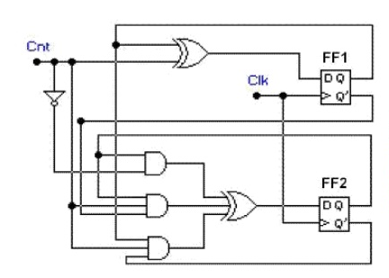

- Consider the following switch-trail ring counter. If the initial output value WXYZ = 0000, what would be value of WXYZ after five successive CLK cycles. Please also complete the given timing diagram [5+5=10 Marks]

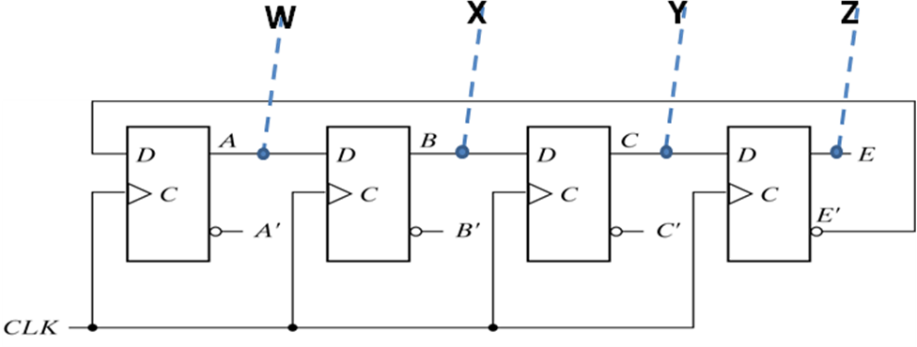

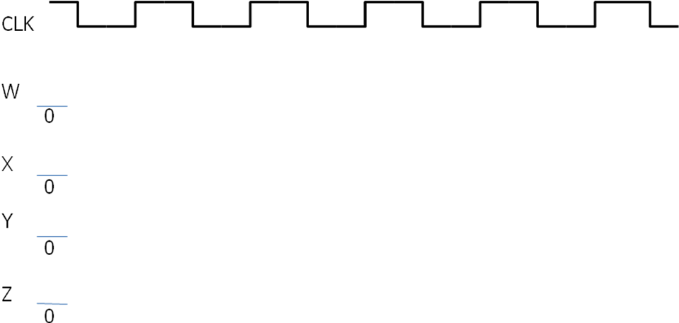

- Design a synchronous irregular counter with JK flip-flops that count the following binary repeated sequence: 0, 4, 2, 7, 3, 1. Please show the detail design procedure as state transition table, state diagram, logic equations and logic diagram [ 3+4+4+4=15 Marks]

- A 16 Kilobyte RAM has a word size of 16 bits. (20 Marks)

(a) How many address bits do the RAM require?

(b) How many D Flip Flops do the RAM require?

(c) Draw a clearly labeled logic diagram of a binary storage cell and describe.

(d) Explain the concept of read and write for a memory unit.

5. Consider the following set of Boolean functions: [10 Marks]
W (p, q, r) = ∑(0,1, 6,7)
X (p, q, r) = ∑(0,3,5,7)
Y (p, q, r) = ∑(2,4)

(a) Deduce the optimal ROM truth table for the above functions.

(b) Draw the ROM logic diagram to implement the circuit.

